# Project Kickoff: Data Storytelling

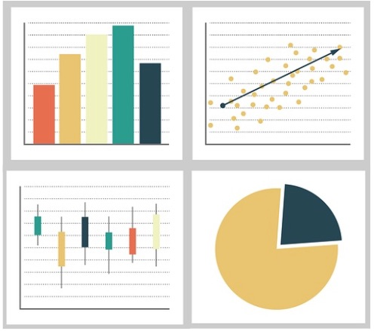

In this project, you will get to tell your own data story. You will create a visually appealing infographic that displays important data visualizations. The infographic will also tell a story based on your interpretation after exploring and analyzing data.

You can choose any topic to start creating your data story. Choose a topic that is of interest or importance to you and will make for a good story!

Here are a few topic suggestions:

* Wildfires and other Natural Disasters
* Effects of Bad Habits on Life Expectancy
* Growth of Cybersecurity Attacks
* Bridge Programs for First-Generation College Students
* Effects of Team-Based Sports for Females
* Effects of Food Desserts (Distance to a Grocery Store)
* Impact of Taking a Summer Gap Year